# ***LAB # 09***

# ***Introduction to HTML Forms and CSS Basics***



**Fall 2022**

**CSE101L Computer Fundamentals Lab**

Submitted by: **Haris Khan**

Registration No. : **60032**

Class Section: **A**

“On my honor, as student of University of Engineering and Technology, I have neither given nor received unauthorized assistance on this academic work.”

Student Signature: ______________

Submitted to:

**Engr. Abdullah Hamid**

January 10, 2023

Department of Computer Systems Engineering

University of Engineering and Technology, Peshawar

***Step#01:***

I coded an HTML and CSS for the given topic.

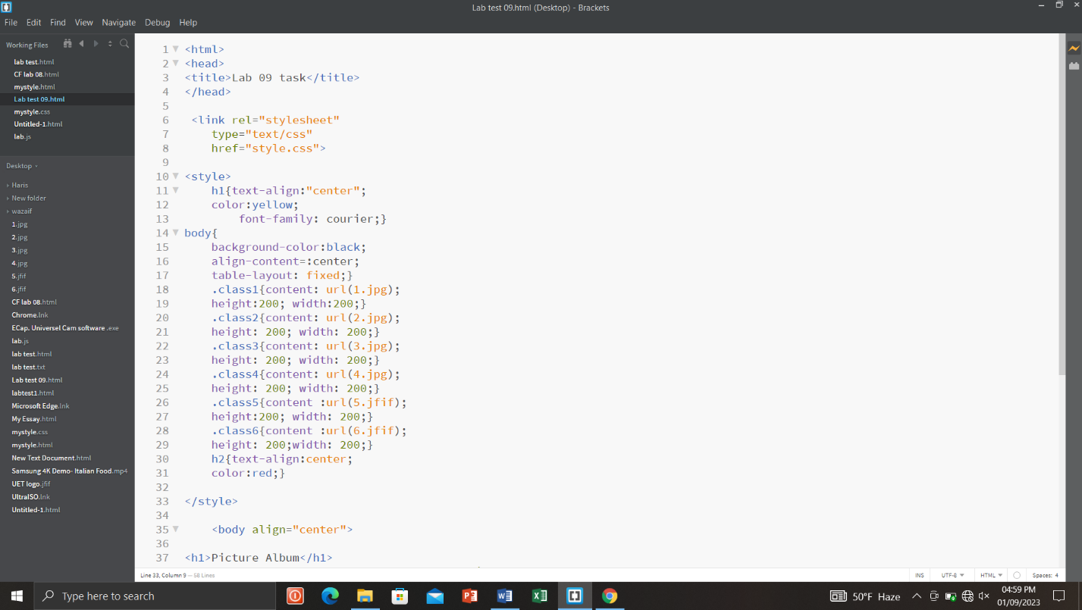

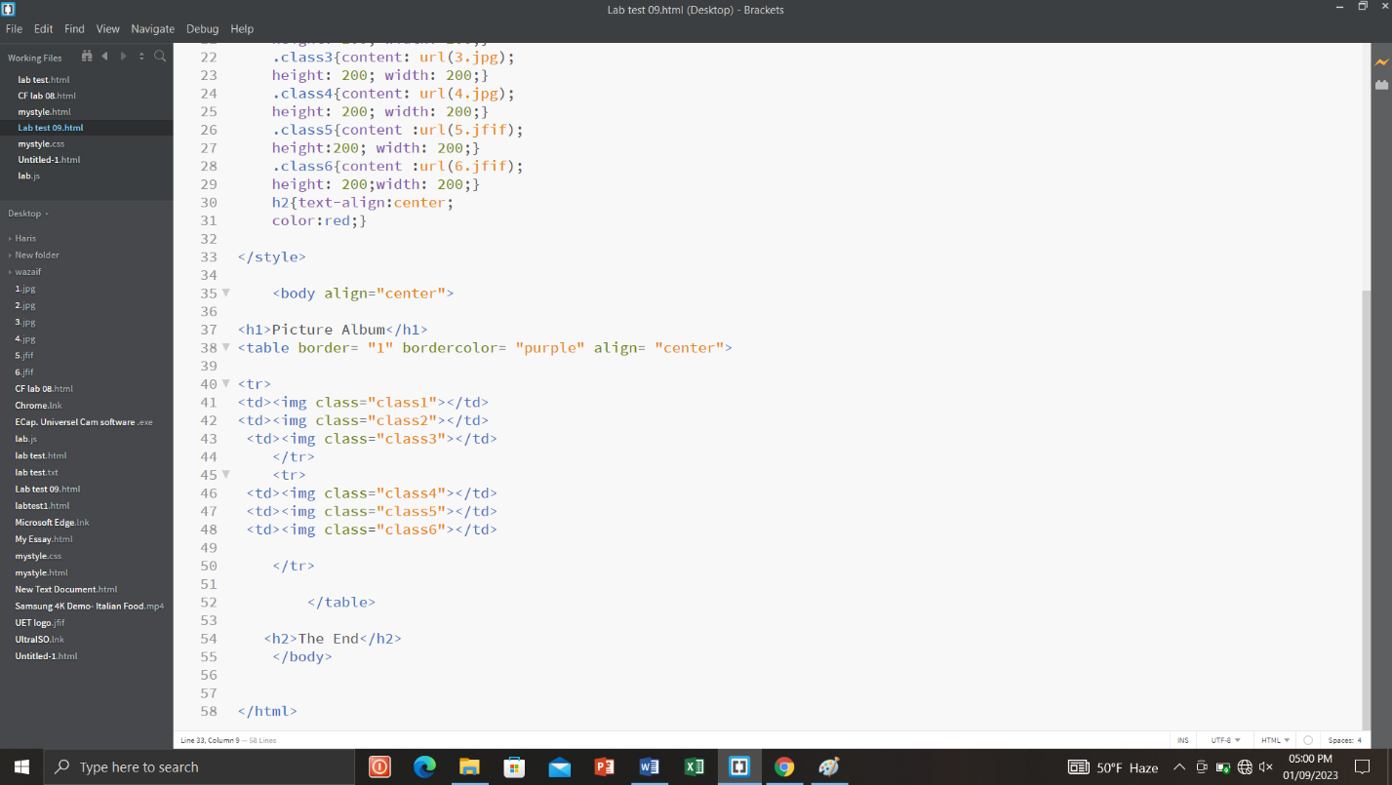

***Step#02:***

I ran the program in the browser.

